Ayush Goyal
190905522 CSE D Roll 62

Computer Networks Lab 5:

Part 1: Study of Domain Name Server:

Aim : To configure a topology of two routers, one as a client and the other as a DNS server to make DNS resolutions.

DNS Client DNS Server

IP Addresses:

Interface: Address:

DNS Client 10.10.10.1/24
DNS Server 10.10.10.2/24

Configurations:

For R1, DNS Client, we set up the ip address at the interface f0/0, aswell as for DNS Server.
We then enable domain name lookup on DNS Client with :
ip domain lookup
and set the default domain address to DNS Server with :
ip name-server 10.10.10.2
In R2, we set it up as a DNS server with :
ip dns server
Now to test the connection, we ping R2 from the R1.

When the connection is successful, we need to test out whether our DNS Server R2 resolves any domain names passed to it via DNS Client R1.

We make a loopback address and assign it a domain of loopback.R2.com, so we can ping loopback.R2.com and check whether our domain is resolved or not by:
ip host loopback.R2.com 2.2.2.2

We assign the loopback an address of 2.2.2.2. To set a loopback we use:
interface loopback 1
ip address 2.2.2.2 255.255.255.255

We need to set one more configuration. The DNS Client R1 should know where to route all its requests so we add the following routing configuration to the forwarding table:
ip route 0.0.0.0 0.0.0.0 10.10.10.2
Now all the requests will be routed to our DNS Sever R2 and when we try to ping 2.2.2.2:

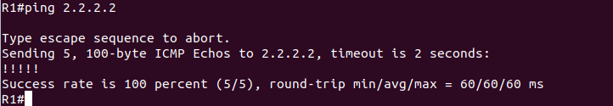
We can also ping loopback.R2.com:

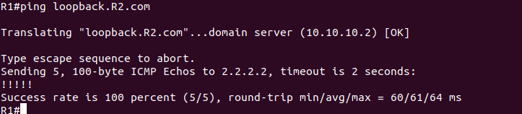
We observe that “Translating “loopback.R2.com”” shows our domain name is being resolved.
We can also observe the DNS request and replies in Wireshark.

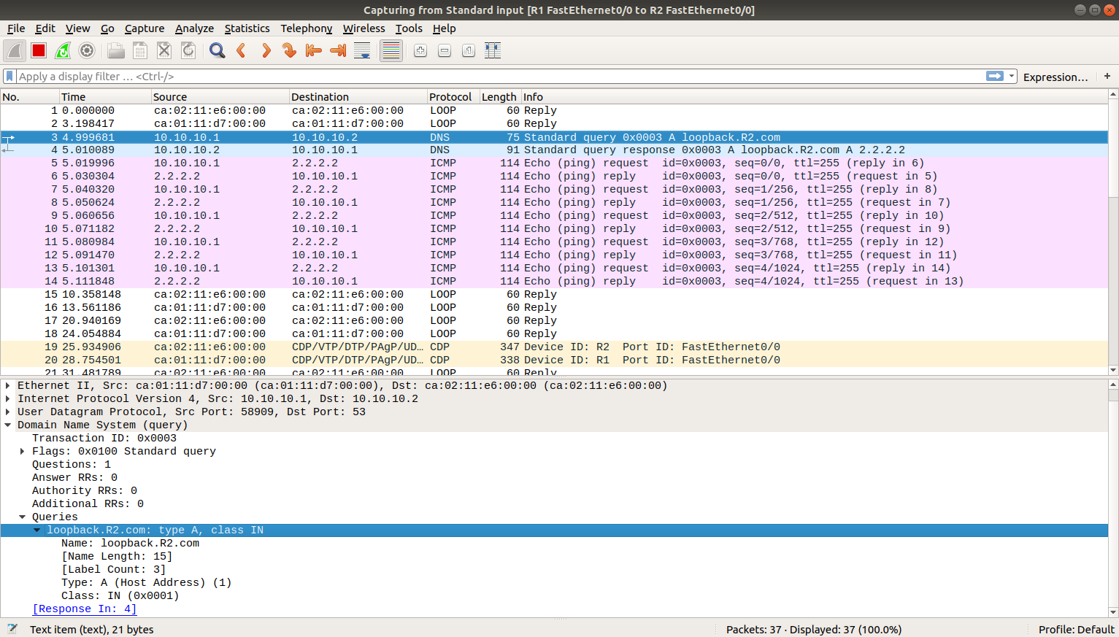

We can observe the request DNS with the name loopback.R2.com and the response DNS with the resolved name and IP address as 2.2.2.2 .

Therefore, we have successfully created a DNS server and tested it out with a DNS client.

Lab Excercise:

Aim: Configure the below DNS Server and DNS Client. Test the setup. Analyze the
Interaction.

Default Router DNS Server
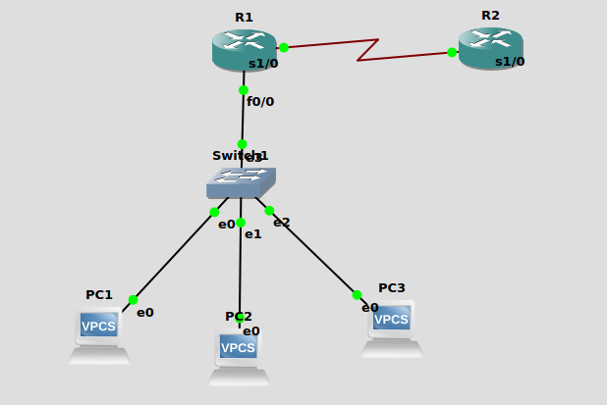

IP Addresses:

Interface: Address:
Default Router R1 s1/0 192.68.1.1/24
DNS Server s1/0 192.68.1.2/24
PC1 11.10.200.2/24
PC2 11.10.200.3/24
PC3 11.10.200.4/24
Default Server f0/0 11.10.200.1/24

Configurations:

We configure DNS Server R2, the same way we did as in the previous example. Here, we add a few things which are as follows :
1. A forwarding rule for the network ID of the different Vms.
ip route 11.10.200.0 255.255.255.0 192.68.1.12.
We add more domain names in the list of domains.
ip host HOST_NAME IP_ADDRESS
For the Default Router R1, we just have to assign the IP Addresses to its interfaces as it immediately and automatically identifies its neighbouring networks, which here is the DNS Server R2.

We can then ping the different domains and see if we get a successful ping.
Part 2: Study of DHCP Server:

Aim: Configure two Vms that will be used to test connectivity from end to end and a router will serve as a DHCP server to distribute IP Addresses.

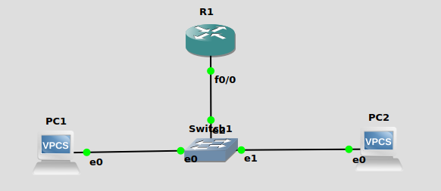

IP Addresses:

Interface: Address:

R1 f0/0 70.29.66.1/24

Configurations:

There is very little configuration required to create a DHCP server.
We need to assign the interface of the router with an IP Address and then we need to create a DHCP pool and specify the network ID with which the Vms will be assigned the address from (along with the subnet mask).

We also specify the default gateway for all the vms as the DHCP router:

ip dhcp pool dhcp_server
network 70.29.66.0 255.255.255.0
default-router 70.29.66.1
Here 70.29.66.1 is the IP Address of f0/0 interface of the server.

Now we run
dhcp
on the vms and see if a valid IP Address is assigned.

As we can observe, the assigned IP address is the correct one withthe network ID as mentioned.

We have to set up R1 as shown in the screenshot below:

Terminal for R1:
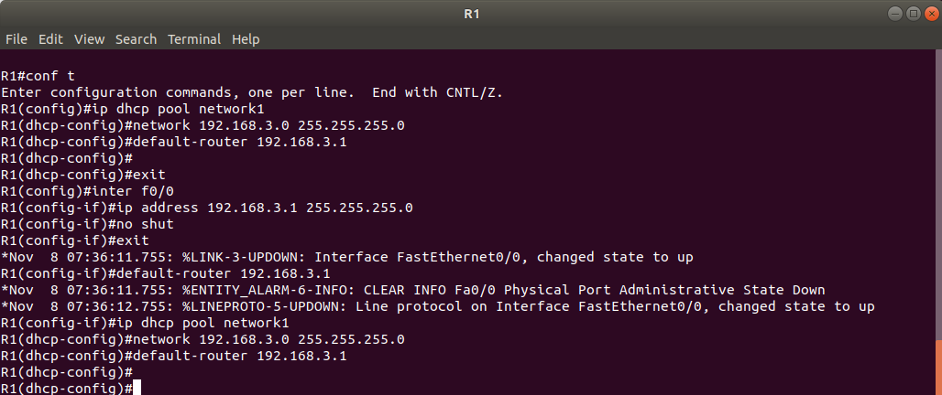
Terminal for PC1:

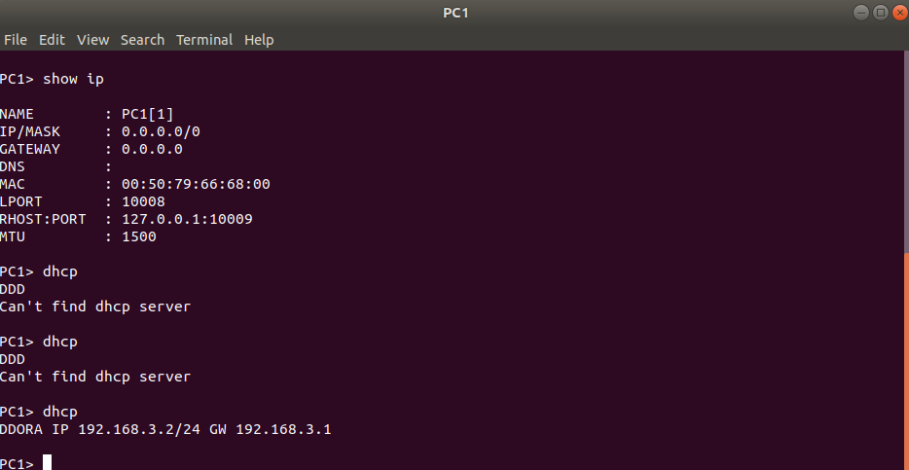
Terminal for PC2:

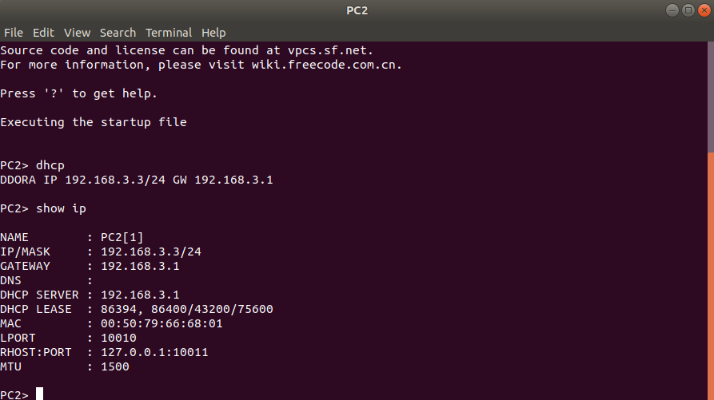

We also observe the packets sent by the VM through wireshark.

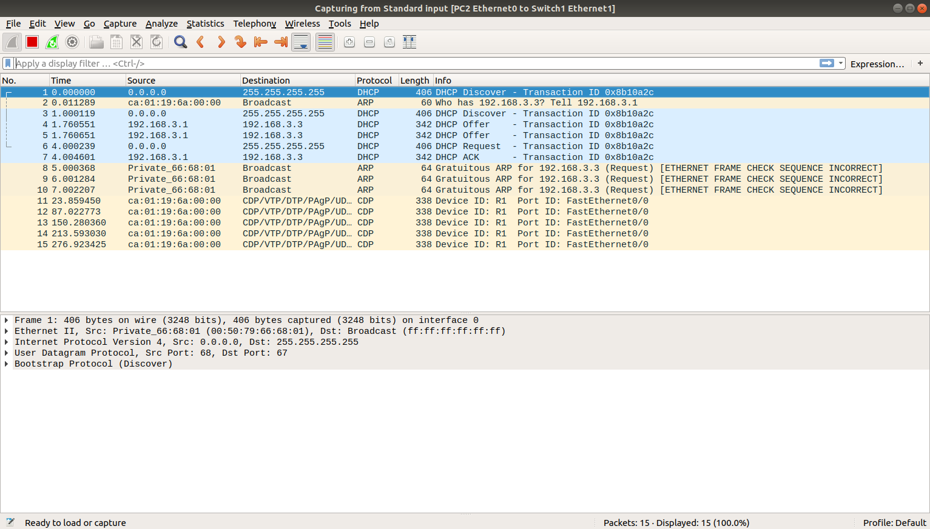

First a discover packet is sent by the VM which helps the server identify that it is looking for an IP Address. (D)
Then the server offers an IP address to the VM. (O)
The Vm in return accepts the address and requests for the lease.(R)
The server at last acknowledges the VM that the ip address has been assigned to it. (A)

THE END

